**CSE421**

**Lab Project**

**Group No: 11**

Topology(hand-draft):

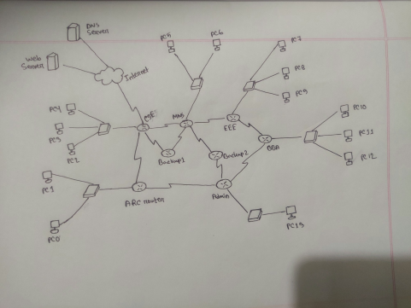

Allocating Network Address:

| Name | Network Address | Slash | Subnet Mask |
| --- | --- | --- | --- |
| Bachelor of Business  Administration | 1.2.8.0 | /22 | 255.255.252.0 |
| Computer Science and  Engineering | 1.2.12.0 | /23 | 255.255.254.0 |
| Electrical & Electronics  Engineering | 1.2.14.0 | /23 | 255.255.254.0 |
| Mathematics & Natural  Science | 1.2.17.0 | /25 | 255.255.255.128 |
| Department of Architecture | 1.2.17.128 | /26 | 255.255.255.192 |
| Central Administrative  Building. | 1.2.17.192 | /27 | 255.255.255.224 |

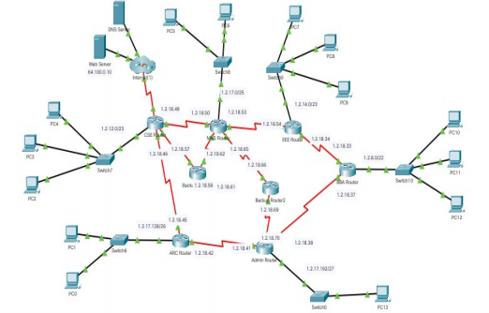

Addressing Table:

| Device | Interface | IPv4 Address | Subnet Mask | Default Getway |
| --- | --- | --- | --- | --- |
| BBA Router | S0/0 | 1.2.18.37 | 255.255.255.252 |  |
| S1/0 | 1.2.18.33 | 255.255.255.252 |  |
| F2/0 | 1.2.8.1 | 255.255.252.0 |  |
| CSE Router | S0/0 | 1.2.18.49 | 255.255.255.252 |  |
| S1/0 | 1.2.18.46 | 255.255.255.252 |  |
| S2/0 | 1.2.18.57 | 255.255.255.252 |  |
| F3/0 | 1.2.12.1 | 255.255.254.0 |  |
| S4/0 | 209.165.200.225 | 255.255.255.252 |
| EEE Router | S0/0 | 1.2.18.34 | 255.255.255.252 |  |
| S1/0 | 1.2.18.54 | 255.255.255.252 |  |

|  | F2/0 | 1.2.14.1 | 255.255.254.0 |  |
| --- | --- | --- | --- | --- |
| MNS Router | S0/0 | 1.2.18.53 | 255.255.255.252 |  |
| S1/0 | 1.2.18.50 | 255.255.255.252 |  |
| S2/0 | 1.2.18.62 | 255.255.255.252 |  |
| S3/0 | 1.2.18.65 | 255.255.255.252 |  |
| F4/0 | 1.2.17.1 | 255.255.255.128 |
| ARC Router | S0/0 | 1.2.18.45 | 255.255.255.252 |  |
| S1/0 | 1.2.18.42 | 255.255.255.252 |  |
| F2/0 | 1.2.17.129 | 255.255.255.192 |  |
| ADMIN Router | S0/0 | 1.2.18.41 | 255.255.255.252 |  |
| S1/0 | 1.2.18.38 | 255.255.255.252 |  |
| S2/0 | 1.2.18.70 | 255.255.255.252 |  |
| F3/0 | 1.2.17.193 | 255.255255.224 |
| Backup Router 1 | S0/0 | 1.2.18.58 | 255.255.255.252 |  |
| S1/0 | 1.2.18.61 | 255.255.255.252 |  |
| Backup Router 2 | S0/0 | 1.2.18.66 | 255.255.255.252 |  |
|  | S1/0 | 1.2.18.69 | 255.255.255.252 |  |
| PC0 | F0 | 1.2.17.131 | 255.255.255.192 1.2.17.129 |  |
| PC1 | F0 | 1.2.17.130 | 255.255.255.192 1.2.17.129 |  |
| PC2 | F0 | 1.2.12.4 | 255.255.254.0 | 1.2.12.1 |
| PC3 | F0 | 1.2.12.3 | 255.255.254.0 | 1.2.12.1 |
| PC4 | F0 | 1.2.12.2 | 255.255.254.0 | 1.2.12.1 |
| PC5 | F0 | 1.2.17.2 | 255.255.255.128 1.2.17.1 |  |
| PC6 | F0 | 1.2.17.3 | 255.255.255.128 1.2.17.1 |  |
| PC7 | F0 | 1.2.14.2 | 255.255.254.0 | 1.2.14.1 |
| PC8 | F0 | 1.2.14.3 | 255.255.254.0 | 1.2.14.1 |
| PC9 | F0 | 1.2.14.4 | 255.255.254.0 | 1.2.14.1 |
| PC10 | F0 | 1.2.8.2 | 255.255.252.0 | 1.2.8.1 |
| PC11 | F0 | 1.2.8.3 | 255.255.252.0 | 1.2.8.1 |
| PC12 | F0 | 1.2.8.4 | 255.255.252.0 | 1.2.8.1 |
| PC13 | F0 | 1.2.17.194 | 255.255.255.224 1.2.17.193 |  |
| Web Server | F0 | 64.100.0.10 | 255.255.255.0 | 64.100.0.1 |
| DNS Server | F0 | 8.8.8.8 | 255.255.255.0 | 8.8.8.1 |